**CODE FOR SERVER**

import java.io.*;

import java.net.ServerSocket;

import java.net.Socket;

public class server {

public static void main(String[] args) throws Exception {

ServerSocket sersock = new ServerSocket(3000);

System.out.println("Server ready for communication");

Socket socket = sersock.accept();

BufferedReader br = new BufferedReader(new FileReader(

" C:\Users\G”urav\Desktop\File_In_Server.txt”));

String k = br.readLine();

DataOutputStream dos = new

DataOutputStream(socket.getOutputStream());

dos.writeUTF(k);

System.out.println("file has been sent");

}

}

**CODE FOR CLIENT**

import javax.swing.*;

import java.awt.*;

import java.awt.event.ActionEvent;

import java.awt.event.ActionListener;

import java.io.*;

import java.net.Socket;

public class client7 extends JFrame {

public client7() {

// File Reader

JTextField jTextField = new JTextField(20);

JLabel jLabel = new JLabel("Connect to remote device");

JButton jButton = new JButton("connect and load file");

//File Player

JFrame fileDisplay = new JFrame("File Display");

fileDisplay.setSize(800, 600);

JLabel fileText = new JLabel();

FlowLayout flowlayout = new FlowLayout();

flowlayout.setVgap(230);

fileDisplay.setLayout(flowlayout);

fileDisplay.setVisible(false);

fileDisplay.add(fileText);

add(jTextField);

add(jLabel);

add(jButton);

FlowLayout flowLayout = new FlowLayout();

flowLayout.setVgap(50);

flowLayout.setHgap(200);

setLayout(flowLayout);

setTitle("File Reader");

setSize(800, 600);

setVisible(true);

setDefaultCloseOperation(JFrame.EXIT_ON_CLOSE);

jButton.addActionListener(new ActionListener() {

@Override

public void actionPerformed(ActionEvent e) {

String ip = jTextField.getText();

try {

if (ip.equals("192.168.29.37")) {

fileDisplay.setVisible(true);

SwingWorker swingWorker = new SwingWorker() {

@Override

protected Object doInBackground() throws Exception {

try {

Socket socket = new Socket("192.168.29.37", 5000);

DataInputStream dis = new

DataInputStream(socket.getInputStream());

String k = dis.readUTF();

File file = new File("fileFromClient.txt");

FileOutputStream fos = new FileOutputStream(file);

byte[] b = k.getBytes();

fos.write(b);

} catch (IOException ioException) {

ioException.printStackTrace();

}

return null;

}

@Override

protected void done() {

super.done();

System.out.println("Received file");

try {

FileInputStream fis = new FileInputStream(

"fileFromClient.txt");

byte[] b = new byte[105];

fis.read(b);

String data = new String(b);

fileText.setText(data);

fis.close();

} catch (IOException fileNotFoundException) {

fileNotFoundException.printStackTrace();

}

}

};

swingWorker.execute();

}

} catch (Exception exception) {

exception.printStackTrace();

}

}

});

}

public static void main(String[] args) {

new client7();

}

}

**OUTPUT**

1)We run the code for server first .

2) then we run the code for the client

3) Write the required IP address to connect to the remote machine .

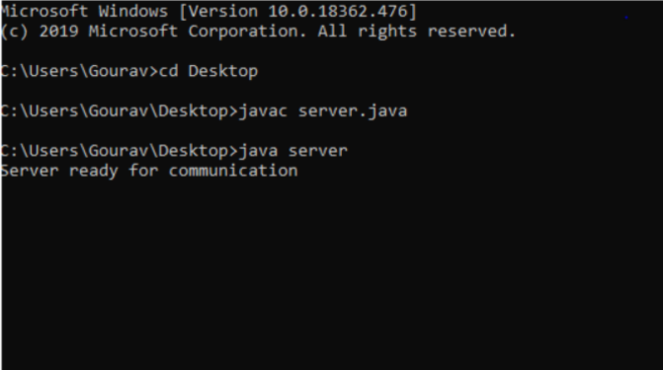

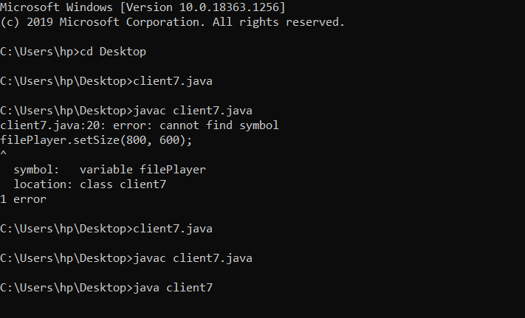

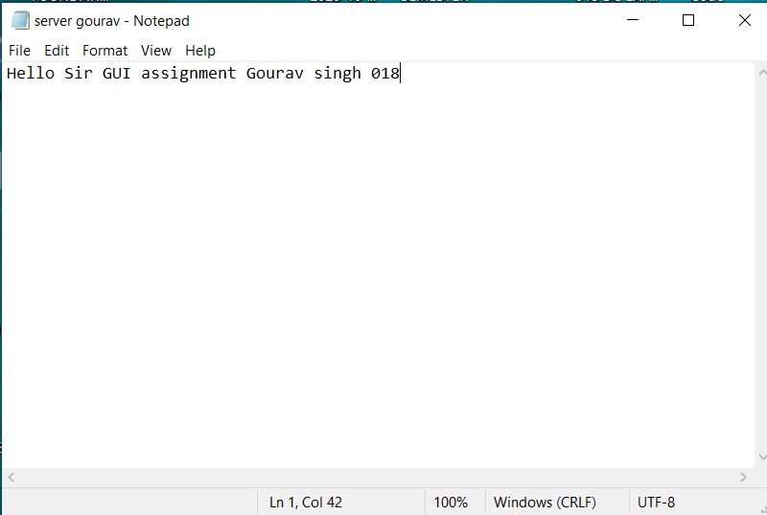

**From the “ server gourav.txt” file the text has been printed on the File Display window created by the java swing/java awt .**

**We put the following IP address in order to connect to the remote machine which then reads the file at that machine and we print it in the separate window.**

